Adding the webdav for Windows XP

Start Windows file manager (aka Windows Explorer)

1. Click My Network Places  
   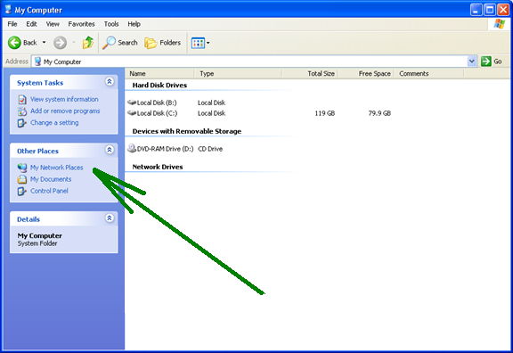
2. Click to Add a network place  
   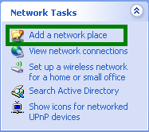
3. Follow the Wizard  
   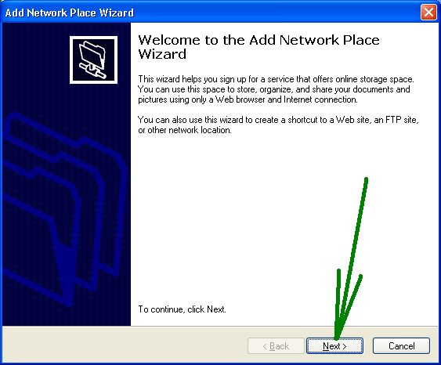
4. Adding a location address  
   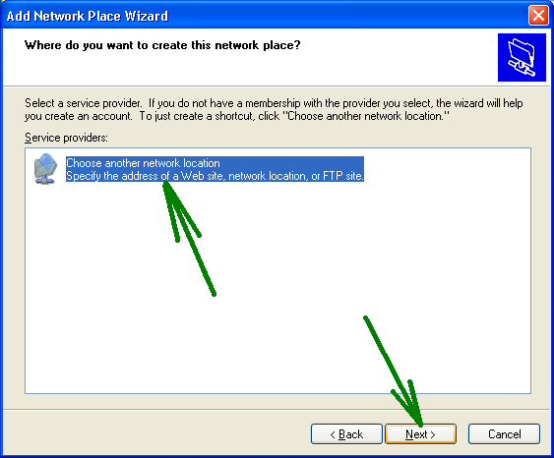
5. Enter the address <https://files.wrir.org/webdav> and click Next  
   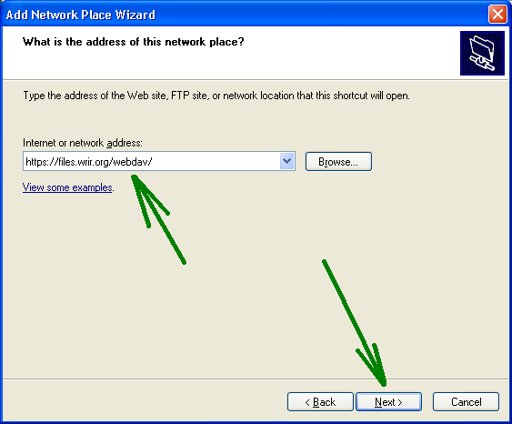
6. WindowsXP will try to connect and will present a security error. The certificate has a self-issued certificate, should be the only error. Click Yes to proceed.  
   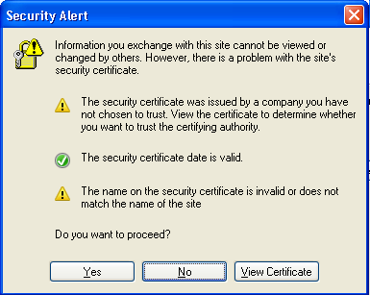
7. Enter your username and password, as sent in the e-mail  
   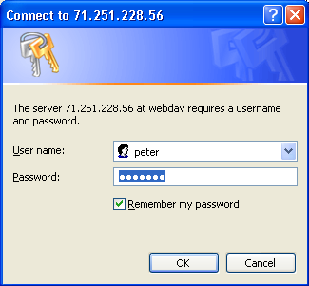
8. When connected, you should see the files in a drag and drop style explorer window  
   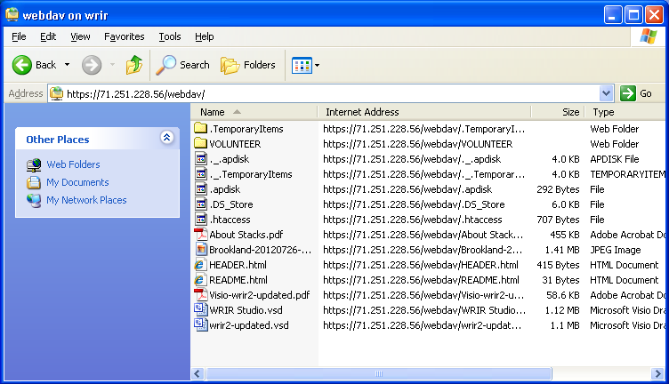
9. Next time, you should have a short-cut in your network places:  
   